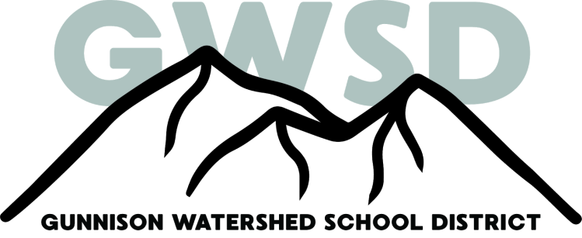
Crested Butte Community School/ 818 Red Lady Ave. PO Box 1285/ Crested Butte, CO 81224/ 970.641.7720

September 13th, 2019
Dear Elementary Families,
I hope this letter finds you all well and that your children are settling into a good school routine. It was a great start from our perspective and it is all systems go from here! Thanks to all who came to our Back to School Night – it was great to see so many families here!
I’m sending out this letter to explain a bit about our instructional program and how we provide academic, social and emotional support for students who may need more than what the general classroom provides.
Our first goal is to provide high quality instruction and curriculum programs for all students in the general classroom. Teachers design their lessons based on academic standards and research-based instructional strategies. They differentiate their instruction for students with varying abilities and learning styles.
We have a built in “Skills Groups/Book Clubs” time each day where students are divided into smaller groups for more targeted reading instruction. During this time students may move to different rooms and work with different teachers based on ability and learning style. Alternatively, our interventionists and EA’s may push in to classrooms to provide individualized support throughout the day.
Skills Groups/Book Clubs will start next week. We have worked really hard to ensure that students are placed in the group that best suits their needs. If you have questions or concerns regarding this information or your child’s educational plan, please contact your child’s teacher or one of the interventionists listed below:
Scottie Earley-Moss – Reading Intervention
Jenny Thomes – Reading Intervention
Susan Beltz – Literacy Curriculum Specialist
Sarah Block – Math Curriculum Specialist
Adrienne Edmunds-Weil – Special Education
Christine Carney – General Education Assistant
Stacey Pennie – GT/Enrichment
Stacey Petersen – School Counselor

Response to Intervention - RtI
When students demonstrate the need for more support or enrichment, we have a system in place called Response to Intervention, or RtI. The RtI Plan takes into account the strengths and needs of the student and includes strategies and targeted interventions to best meet those needs. The plan includes academic accommodations, alternative learning environments, small group or individual instruction, and specific, research-based intervention programs. If the development of a plan is deemed necessary, parents will be contacted and included in this process. Typically, RtI Plans are shared at Parent/Teacher Conferences.
I hope this information helps shed some light on some of the systems and programs we have in place to best support your child. As always, I welcome your questions, concerns and comments. I know that parents can sometimes feel disconnected with what is happening in the school. We want to be as transparent as possible with parents, students and our community.
That’s it for now! Enjoy your weekend!
Sally
Sally Hensley
Elementary Principal
Crested Butte Community School
shensley@gunnisonschools.net
970.641.7720 x6309

